

OPP - Creating Installers

Denis SAUNIER, Geoffrey BERGE,
Thibaud LAMARCHE, Thomas BERTHOME

June 04, 2014


Referring professor: Agnès ARNOULD

Table des matières
OPP - Creating Installers 1
Creating Installers 3
Windows 3
Download link: 3
Requirements: 3
Building: 3
Debian/Ubuntu 9
Download link: 9
Requirements: 9
Building: 9
Mac OSX 14
Requirements: 14
Building: 15

Creating Installers

Windows
To create an installer for Windows, we use the software Inno Setup Compiler. Inno Setup Compiler is a software released under a free license, it works on several versions of Windows (from Windows 2000 to Windows 8) 32 and 64 bits. It manages the installation, uninstallation, and custom installations (Full Compact, Custom,...) and creates shortcuts and multilingual management.

Download link:
http://www.jrsoftware.org/isdl.php

Requirements:
You must compile OPP in release mode, retrieve the plugins folder of VLC and the libvlc dll. Then you need to get the MinGW dll and GCC dll then the adequate dll for Qt.

Building:
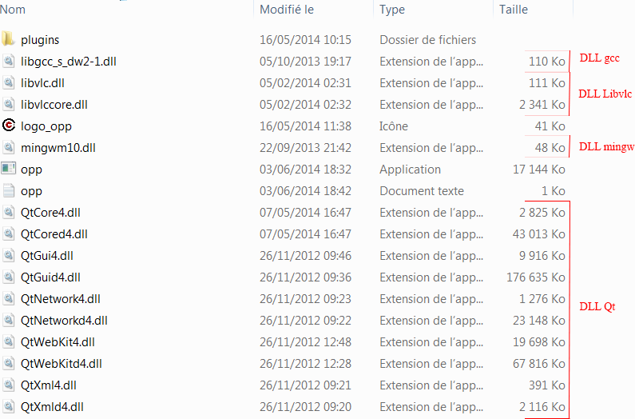
Your installation folder is ready, you can start “Inno Setup Compiler”. You must choose “Create a new script file using the Script Wizrad” and press OK then "NEXT".
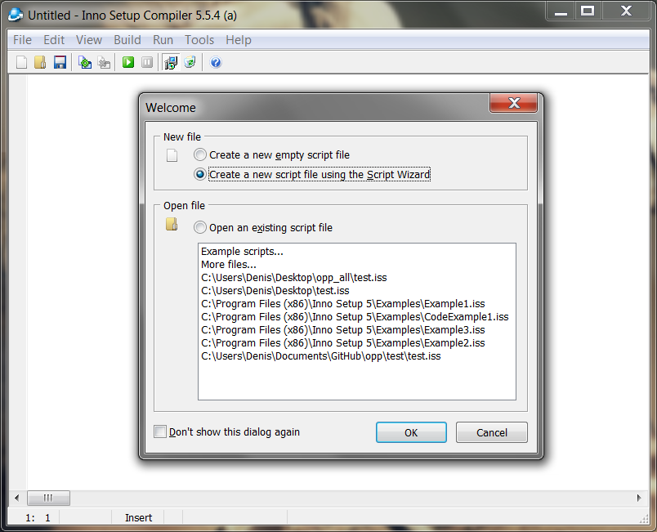
In the following window, you can to fill the application name, his version and the name of the organization. Then press "NEXT".
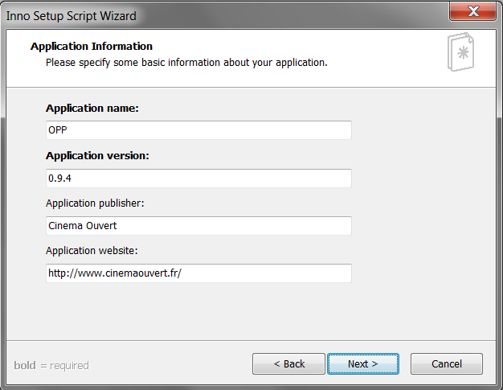

In the following window, you have to choose the installation folder of OPP (Default: Program Files). Then press "NEXT".
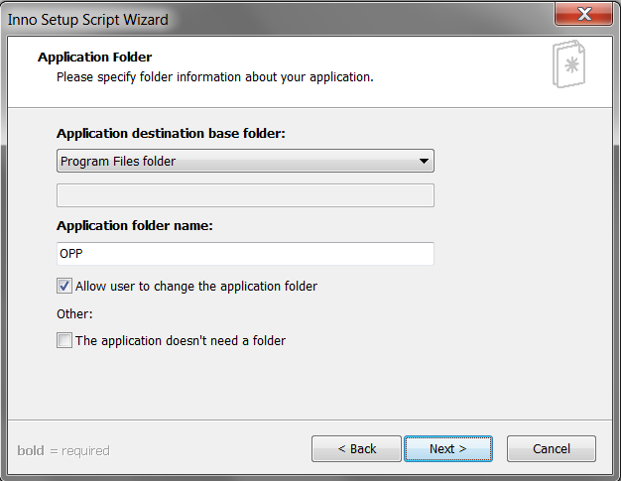
In the following window, choose the executable OPP then add the folder with Dlls and VLC plugins that you have prepared. Then press "NEXT".
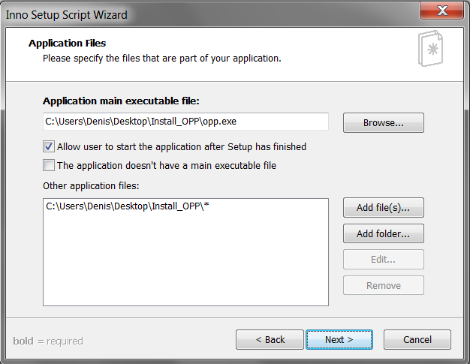

In the following window, you have to choose the name of the folder that will be created in the Start menu. Then you can create desktop shortcuts for the Uninstall. Then press "NEXT".
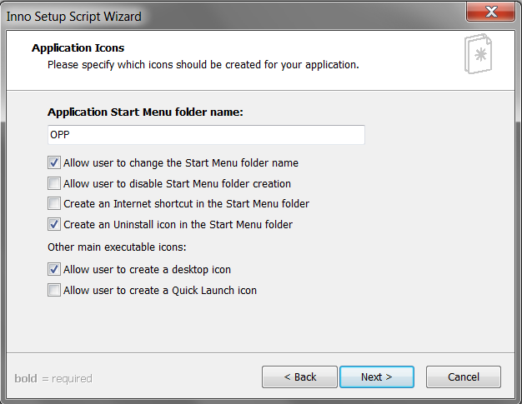
In the following window, you can add the license for OPP. Then press "NEXT".

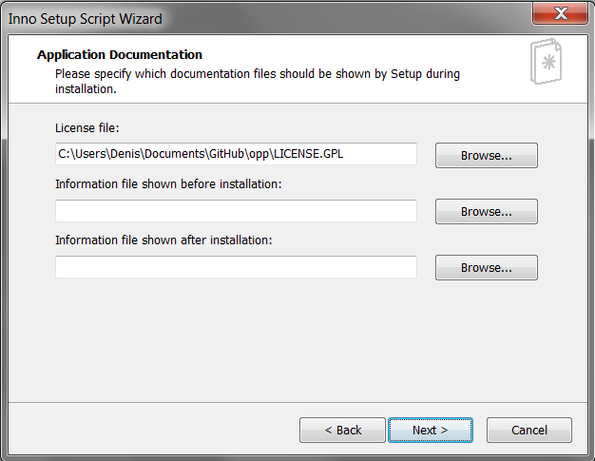

In the following window, you can add languages for installation of OPP. Then press "NEXT".
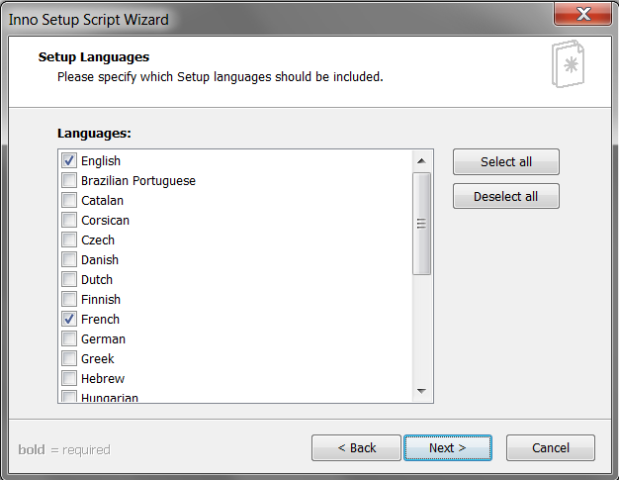
In the following window, you have to choose the name of the installer and then you can put an icon to it. Then press "NEXT".
Finally, press “NEXT” then “FINISH”. The software asks you to compile, press “NO” if you want to add an icon for the software.
In the generated script, there is a tag [Icons] for each of the lines below add at the end:
; IconFileName: "{app} \ logo_opp.ico"

Now you can compile the script, go to the “Build and Compile” menu. An “Output” folder will be created on your desktop with the installer.

Debian/Ubuntu
To create an installer for Debian or Ubuntu, download “Debreate package”, it is an open source software.

Download link:
http://debreate.sourceforge.net/?page=download

Requirements:
You must compile OPP in release mode to generate the adequate executable for the operating system.

Building:
Start “Debreate” and open the project "OppDebian.dbp". It starts a window with all the informations filled.

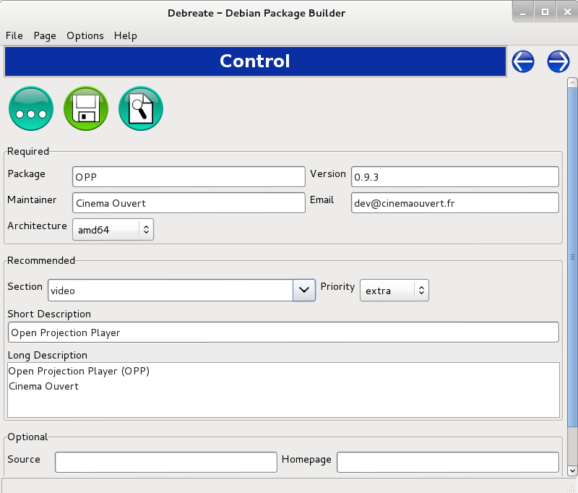

The following window shows the dependencies to install the package. In which you need to add the necessary libraries (it should be already loaded).
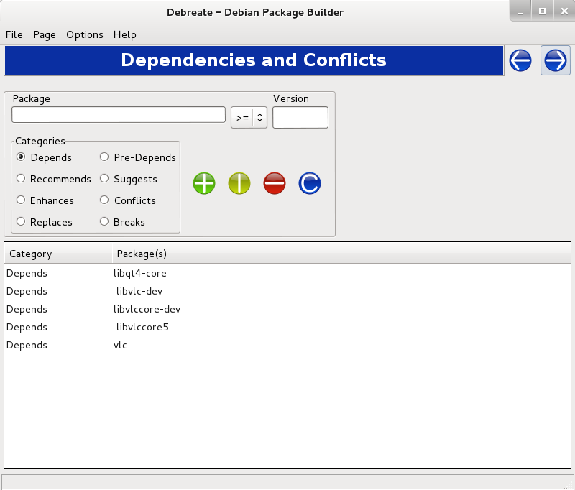

The following window shows the files required to install the package. Add executable, icon.
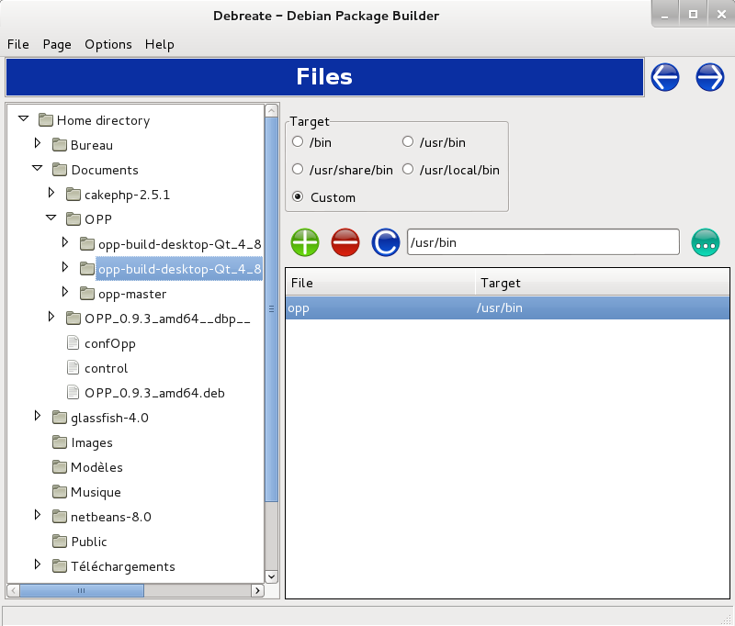

The following window shows logs for the package creation.
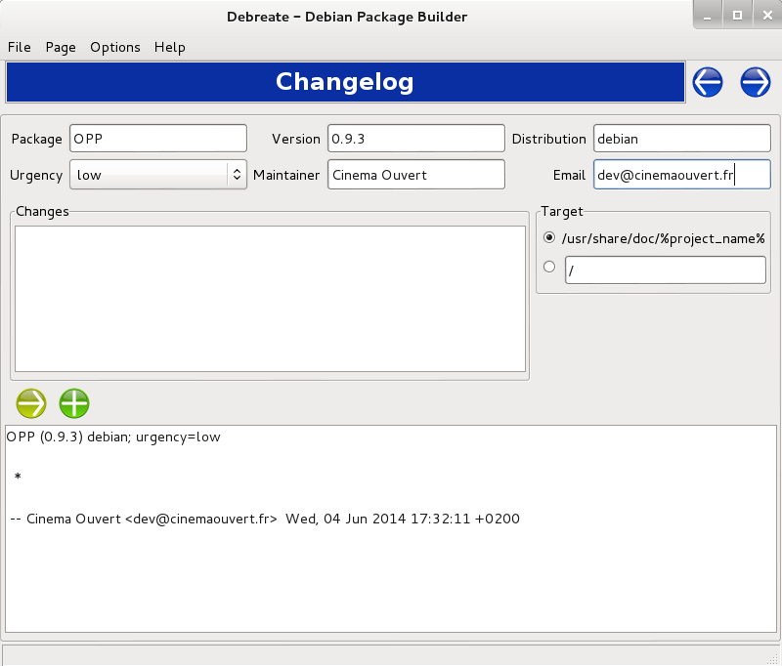

The following window shows the license of the software, copy the opp license in this window.
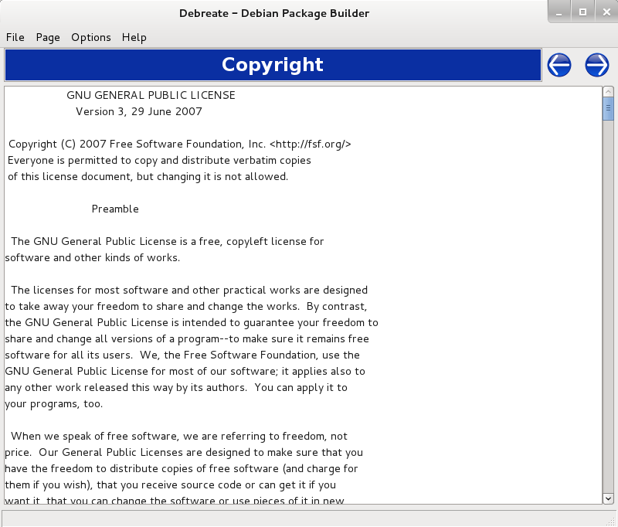

The following window shows the menu launcher, you need to add path to icon and category.
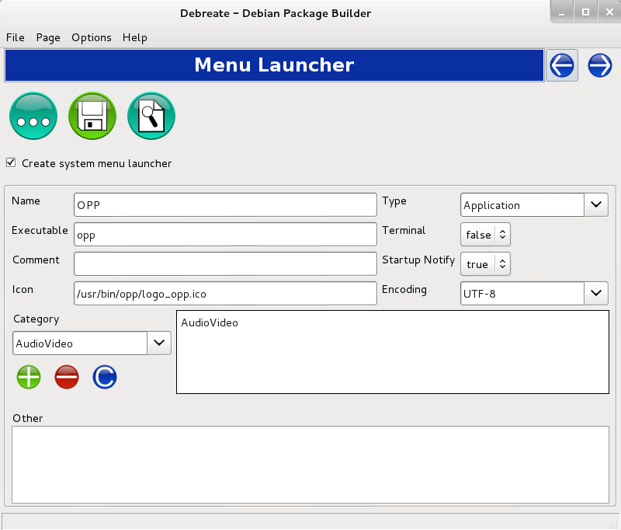

The following window shows the building step, choose create md5sums file and press build button.
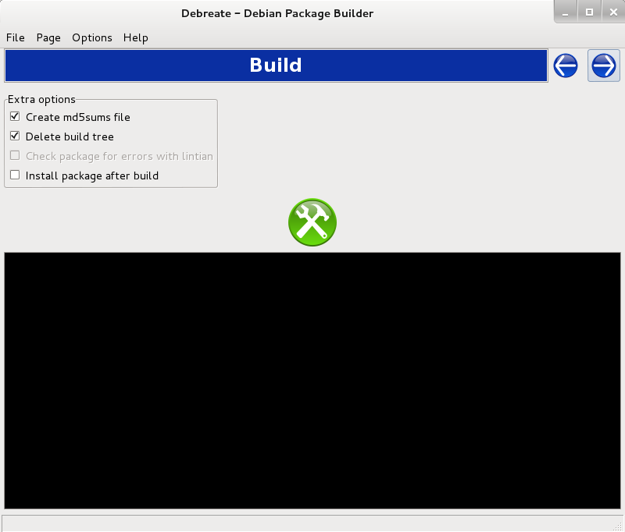

The deb file is generate with the name of operating system with his version and his architecture.

Mac OSX
To create the installer for a mac we used “Package Maker” an embedded software in OSX.

Requirements:
You must compile OPP in release mode to generate the adequate executable for the operating system.
Once that is done, you have to open the contents of the application this generated, located in your compilation folder. It must look like “QTXXXX-Release/opp.app”. To open the content you have to do a right click on opp.app and select “Display the content of the package” . Then you need to copy the folders “plugins” and “libs” from “/Applications/VLC.app/content/MacOs” and paste these in to “opp.app/content/MacOs”.
Finaly you need to create the folder “Frameworks” in “opp.app/content/”. Now you need to copy several folders into that folder, here is the list (take the whole folder):
/Library/Framexorks/QtCore.framework
/Library/Framexorks/QtGui.framework
/Library/Framexorks/QtNetwork.framework
/Library/Framexorks/QtWebKit.framework
/Library/Framexorks/QtXml.framework
/Library/Framexorks/QtXmlPatterns.framework
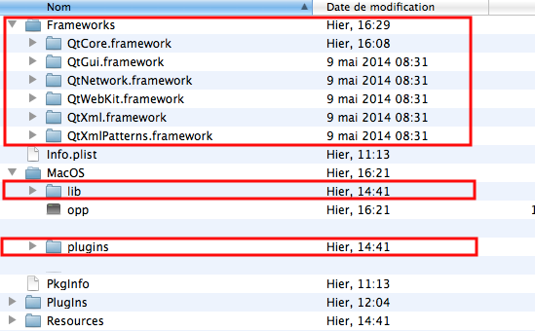
The opp.app must look like this:

Building:
Open the file “OppPackageMaker.pmdoc” from the folder “Installers/Mac/” of the github with PackageMaker.
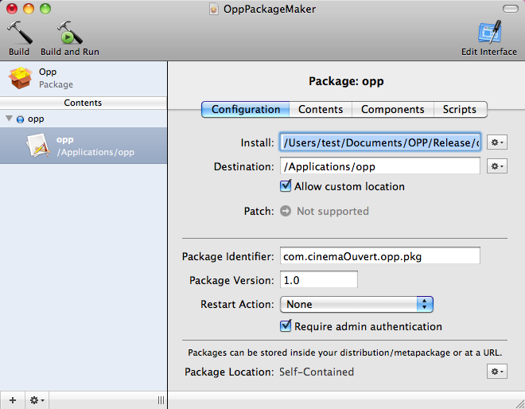
This project is all set up you just have to change the path to the opp.app where it is hilighten “Install:XXXX” and put your path to the opp.app.
If you want to modify the interface of the installer click on “Edit Interface” from the upper right corner and follow instructions.

